**CREATION OF VIEWS AND ASSERTIONS**

CREATE TABLE BANK_EXP12_CSA_41 (BANK_CODE VARCHAR(3) PRIMARY KEY, BANK_NAME VARCHAR(10) NOT NULL, HEADOFFICE VARCHAR(20), BRANCHES INT CHECK(BRANCHES>0));

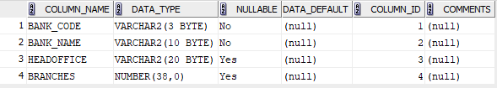

INSERT INTO BANK_EXP12_CSA_41 VALUES('SBT','STATE BANK','MUMBAI',98);

INSERT INTO BANK_EXP12_CSA_41 VALUES('SIB','SOUTH','PUNE',100);

INSERT INTO BANK_EXP12_CSA_41 VALUES('HDF','HOUSING','ERNAKULAM',55);

INSERT INTO BANK_EXP12_CSA_41 VALUES('SBI','BANK INDIA','ERNAKULAM',60);

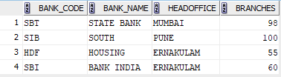

CREATE TABLE BRANCH_EXP12_CSA_41 (BRANCH_ID INT PRIMARY KEY, BRANCH_NAME VARCHAR(20) DEFAULT'NEW DELHI', BANK_ID VARCHAR(3), FOREIGN KEY(BANK_ID) REFERENCES BANK_EXP12_CSA_41 (BANK_CODE) ON DELETE CASCADE);

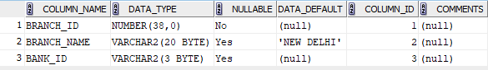

INSERT INTO BRANCH_EXP12_CSA_41 VALUES(1,'KOTTAYAM','SIB');

INSERT INTO BRANCH_EXP12_CSA_41 VALUES(2,'TRIVANDRUM','SBT');

INSERT INTO BRANCH_EXP12_CSA_41(BRANCH_ID,BANK_ID) VALUES(3,'HDF');

INSERT INTO BRANCH_EXP12_CSA_41 VALUES(4,'KOZHIKOD','SBI');

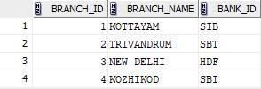

DELETE FROM BANK_EXP12_CSA_41 WHERE BANK_CODE='SBT';

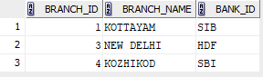

ALTER TABLE BRANCH_EXP12_CSA_41 DROP PRIMARY KEY;

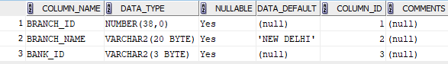

CREATE VIEW BANK_HEAD_OFFICE AS SELECT * FROM BANK_EXP12_CSA_41 WHERE HEADOFFICE='ERNAKULAM';

SELECT * FROM BANK_HEAD_OFFICE;



CREATE VIEW BANK_BRANCH_EXP12_CSA_41 AS SELECT B.* FROM BANK_EXP12_CSA_41 B JOIN BRANCH_EXP12_CSA_41 C ON B.BANK_CODE=C.BANK_ID WHERE BRANCH_NAME='KOTTAYAM';

SELECT * FROM BANK_BRANCH_EXP12_CSA_41;

